The Paris Summit Agenda to Deliver on a New Global Financing Pact
Amar Bhattacharya, Vera Songwe and Nicholas Stern
June 20, 2023

This note is intended to provide a framework for the call to action on a new global financing pact to deliver on the urgent goals on climate and sustainable development. It starts by setting out the purpose of finance, which is to scale up and realign investments for the green transformation and unlock the growth story of the 21st century. It then sets out a new approach for delivery of this finance by tapping the complementary strengths of the different pools of finance. Finally, it highlights the six priorities for action that underpin the Summit and that can together deliver on our collective ambition.
- Purpose of finance: Investment and the new growth story

- A major and sustained investment push is urgently needed to overcome the present multiple crises, restore momentum on poverty reduction and the SDGs, and act at the scale and pace necessary to deliver on the Paris climate goals.
- Altogether, spending on climate-related development goals will need to increase four-fold from the pre-pandemic levels by 2030—to $2.4 trillion per year by 2030 for emerging markets and developing countries other than China. This investment has three key purposes: the transformation of energy systems; responding to the growing vulnerability of developing countries to climate change; and investing in natural capital and sustainable agriculture. Overall development spending to reach the SDGs will need to more than double from pre-pandemic level to around $5.3 trillion per year by 2030 (which includes the $2.4 trillion).
- This investment push led by the green transition can unlock the growth story of the 21st century, full of innovation and better forms of economic growth: more resource efficient; with lower energy costs; better health; and more productive transport, city and land and ecosystems. Much more sustainable, inclusive, and resilient than the past.
- Failure to act at the scale and urgency needed will be deeply dangerous, putting the climate goals out of reach and with severely adverse impacts on lives and livelihoods, especially of poor and vulnerable people everywhere. This decade is decisive.

- A new approach for delivery: complementary finance

- The Paris Summit offers a tremendous opportunity to set out a new architecture of complementary finance to deliver on this ambition. Internal and external. And within external, private, MDBs and concessional.
- The scale of the investments needed in EMDCs over the next five years and beyond will require a debt and financing strategy that: tackles festering debt difficulties, especially those of poor and vulnerable countries; and leads to a major expansion and revamp of both domestic and international finance, public and private.
- An overall financing strategy must utilize the complementary strengths of different pools of finance to ensure the right scale and kind of finance and reduce the cost of capital rather than simply focusing on the aggregate number.
- It must embody a holistic and comprehensive approach to climate finance; It must align all finance with sustainability, including climate goals; and it must create the necessary partnerships to deliver concrete results.
- The attached tableau sets out the scale and composition of the investments that are needed and the targets of the different pools of finance that working together can finance the investment ambition to deliver on climate and sustainable development. External finance by 2030 for these purposes to EMDEs outside China will have to be around $1 trillion per annum with, 500-600 billion private, 250-300 billion MDBs and other development finance, 150-200 billion of concessional and debt-free finance.

- Creating the highways of delivery: six priorities of action

- The overall framework for realising investment and its finance will require platforms for concerted and cooperative action in countries. These platforms will be country-led and create a positive and purposive investment climate and a structure for scaling up investments with involvement of all stakeholders, public and private. Just Energy Transition Partnerships are key examples. Global and regional initiatives, consistent with country action, will be key for important sectors and issues, such as energy and resilience and the mobilization of private finance.
- Tackle the immediate debt difficulties of poor and climate-vulnerable countries and break the vicious cycle of climate and debt vulnerability.
- Support developing countries in their efforts to strengthen domestic resource mobilization, public and private, and tackle illicit capital flows.
- Unleash the potential of the multilateral development banks and the larger development finance system. MDBs and development finance institutions can play a central role in helping countries to create the necessary conditions for scaling up investment and mobilizing the necessary financing from their own resources, tripling their financing flows in the next five years, and even more importantly by catalyzing private finance through the management, reduction and sharing of risk, to reduce the cost of capital. For this, fundamental changes will be necessary in their approach, including in their operating model and how they work together and with the private sector, as well as in the support that they will need from their shareholders. Given the scale of the necessary increase in their own and catalytic financing, MDBs will need additional capital resources even as they pursue more effective use of their existing capital.
- Create a new highway for private finance that can and must make the largest contribution to the scaling up of finance. Need to shift from the present “blame the other” approach to a proactive engagement with the private sector to co-create investment opportunities, tackle impediments, put in place effective risk mitigation structures that can go to scale, and use blended finance judiciously to bring down the cost of capital. There is an urgent need to develop and scale up effective risk mitigation instruments including for foreign exchange risk, revenue risks such as for offtake of renewables and lack of creditworthiness of utilities, and the small size and diffuse nature of many green investments. The financial system must transform so that it is aligned with sustainability and that it serves everyone.
- Greatly expand the scale of concessional and debt-free finance through renewed donor commitment and tapping new sources of concessional and debt free finance that can enhance the volume and predictability of such finance including enhanced use of SDRs, tapping voluntary and compliance carbon markets, fostering and leveraging private philanthropy, and pursuing options to tax fossil fuel use globally including in the maritime and aviation sectors. Must respond to immediate priorities such as the delivery of the $100 billion climate finance commitment in 2023, the IDA cliff-edge, the replenishment of the Green Climate Fund, and support for the PRGT, and set up the basis to tackle gaps in the concessional finance architecture.

Investment / Spending Requirements for Climate and Sustainable Development
$ Billion Per Annum by 2030 (increment from current in parentheses)
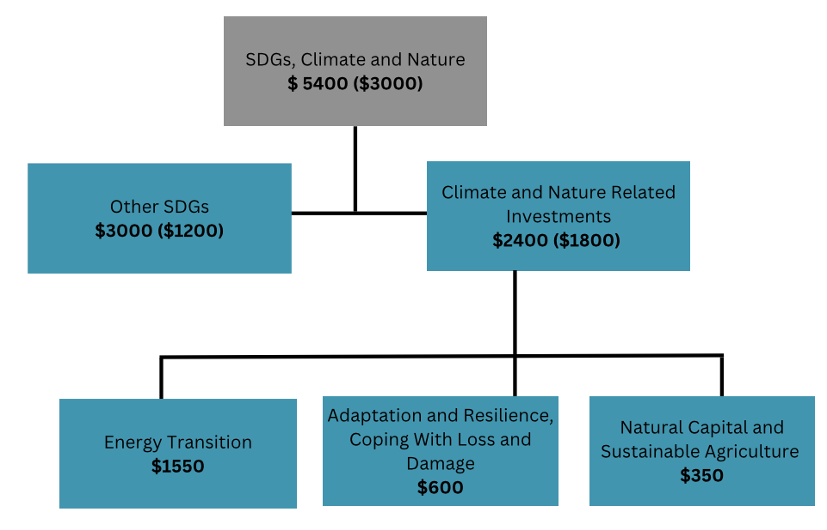

Financing the Green Transition
$ Billion Per Annum by 2030 (increment from current in parentheses)

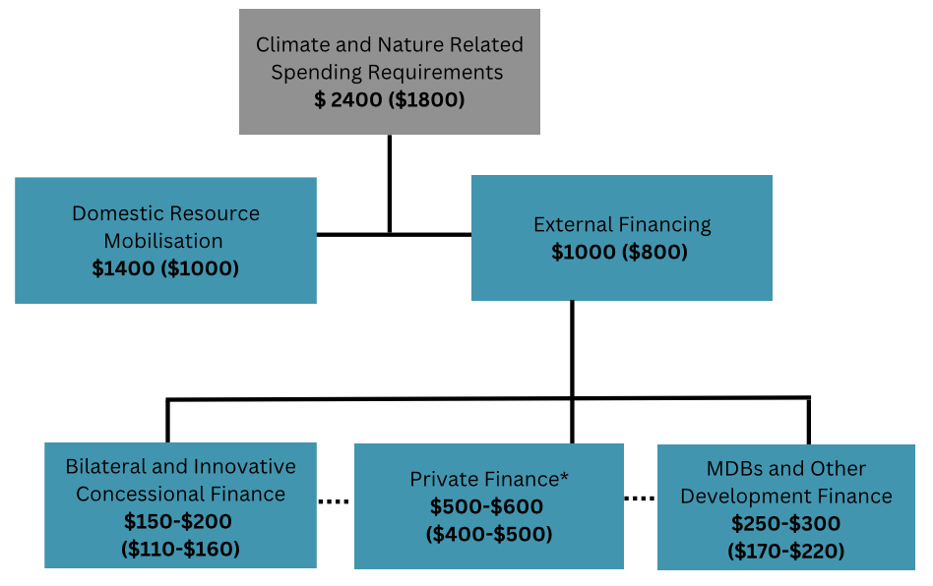
*More than half of this private finance would be directly and indirectly catalysed by MDBs, other development finance institutions, and bilateral finance.

